# Final-project--Group-8

We are planning to do a data analysis on crime incidents across the different nations

Our questions towards our progress:

* The trend for crime rate since 2000
* The factors have correlation with the crime rate
* Areas that have the highest crime rates
* The police forces within the areas
* Any important regulation policies that specific impacted on the crime rates
* Any recommendations with reducing the policy

Sample data:

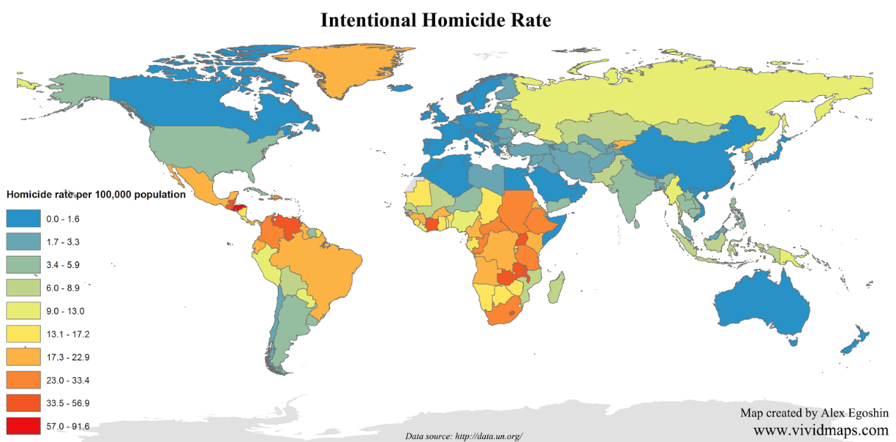

Possible tools: Spyder, Colab, Tableau

Source of Data: https://www.kaggle.com/search?q=crime+tag%3A%22crime%22